**Evidence for Analysis & Design Unit**

Name: Olga Maunsell

Cohort: E18

**A.D 1 – A Use case diagram – Online Pizza Delivery System**

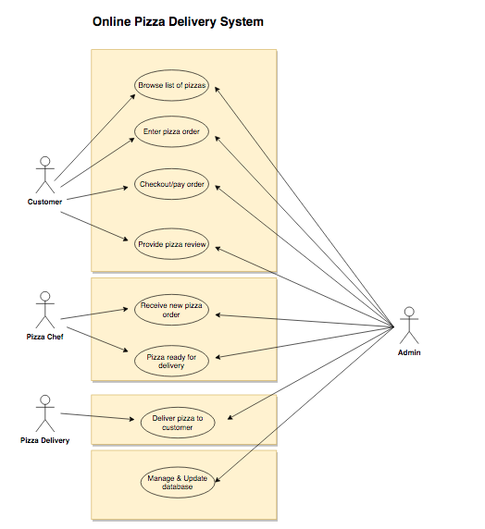

**A.D 2 – Class Diagram – Money Tracker App**

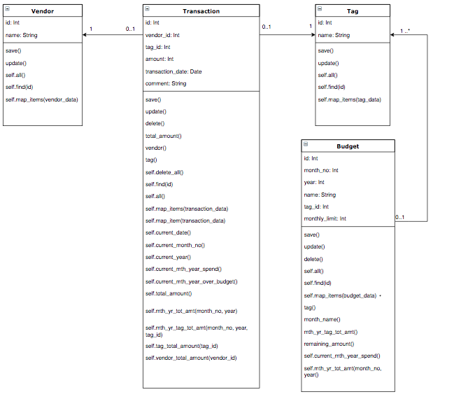

**A.D 3 – Object Diagram – Money Tracker App**

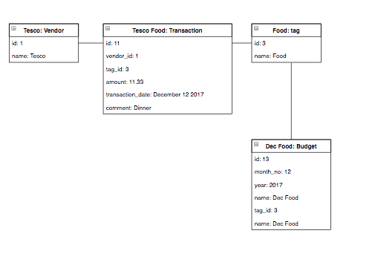

**A.D 4 – Activity Diagram**

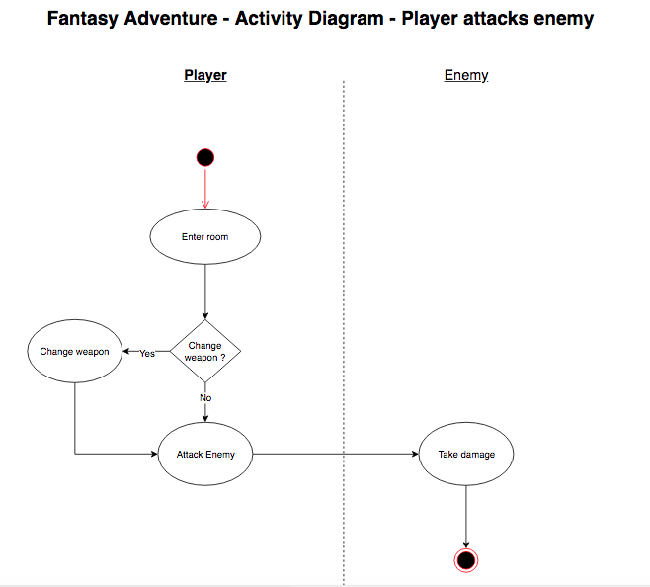

**A.D 5 - Inheritance Diagram**

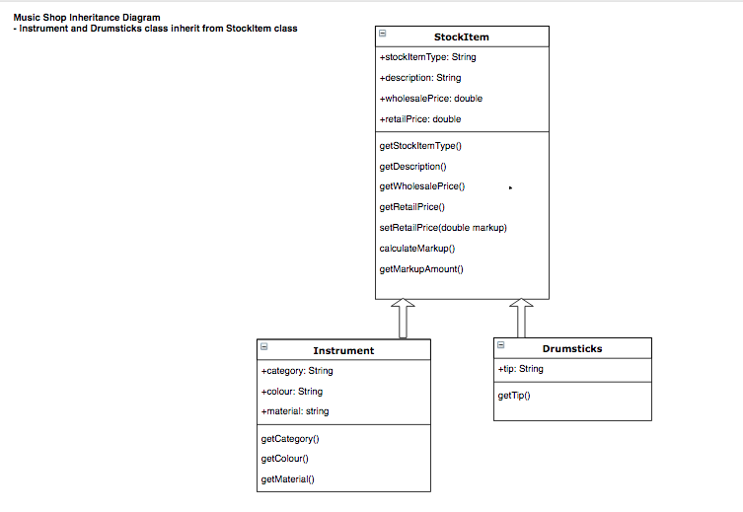

**A.D. 6 - travelingo Project - Implementation Constraints**

|  |  |  |
| --- | --- | --- |
| **Constraint** | **Possible effect of constraint on product** | **Solution** |
| Hardware and software platforms | Web app requires wifi to perform api requests to translate phrases, access country information and weather | Provide user documentation to clarify wifi access is required. A reduced app could be provided which displays only phrases that user has stored in the database. |
| Performance requirements | If the user stores large number of phrases for each language it could cause a delay in displaying the information to the screen. | Provide user documentation to clarify that large number pf phrases stored could cause a delay and recommend deleting phrases not required. In addition a “loading” icon can be displayed to keep user informed while the database is loading information. |
| Persistent storage and transactions | This version of the product which uses a mongo database is not designed for a large number of phrases to be stored in the database. | Provide user documentation clarifying database constraints. If a large volume database is required, a new database design should be considered for the next version. |
| Usability | Not all languages listed have a voice to speak the phrase | Disable the speak button for languages where is no voice for that language and provide user documentation with the latest language list that has a voice to speak the language. |
| Budgets | CodeClan project had no budget available. All tools/technologies needed to be existing tools already obtained by students. | Make use of all free tools/languages available. For example access to free apis. |
| Time | Project to be delivered in 1 week | Initial planning session to discuss and confirm MVP to be delivered and any extensions if time available. Daily planning sessions to confirm project is on track to be delivered to timescales. |